Community Action Advisory Board Application | 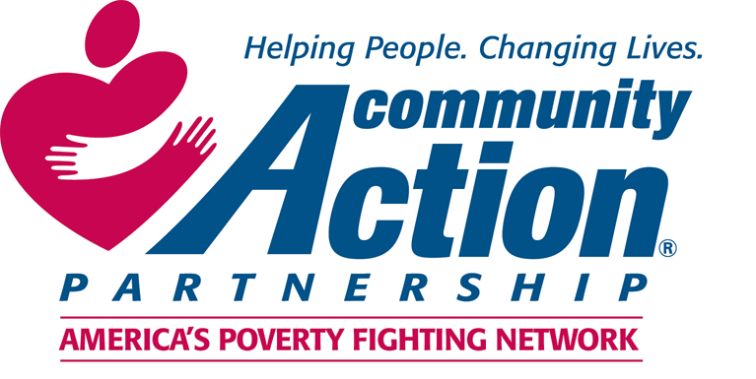

Contact Information
Name
Street Address
City, State, Zip Code
Preferred Phone
E-Mail Address

Board Member Position

Which Clark County Councilor District do you reside in? See page 4. For more clarification, an interactive map of the districts can be found at https://goo.gl/ey5hWK.
☐ 1st ☐ 2nd ☐ 3rd ☐ 4th

What position are you applying for?
☐ Elected Official ☐ Community Representative ☐ Low-Income Representative

Availability

CAAB meetings are currently held on the second Tuesday of odd numbered months (January, March, May, etc), but will move to the first Tuesday starting in May. Meetings are from 8:00am to 10:00am with an occasional extra meeting in funding years (every three years) and opportunities to participate in subcommittees outside of regular meetings. The January meeting typically includes additional trainings and is scheduled for a full day. Does this create any barriers for you? Please explain.

Interest

Please indicate any areas in which you have experience or interest in. Choose up to 3:
☐ Food Assistance | ☐ Affordable Housing | ☐ Homelessness Services
☐ Employment Services | ☐ Energy Assistance | ☐ LGBTQ+ Services
☐ Transportation Assistance | ☐ Education Services | ☐ Youth Activities
☐ Physical Health Services | ☐ Legal Assistance | ☐ Child Care
☐ Mental Health Supports | ☐ Substance Use Supports | ☐ Senior Services
☐ Domestic Violence Services | ☐ Asset Building (business or home purchase, credit repair, etc)

Please tell us why the above areas interest you.

Special Skills or Qualifications

Tell us about your experience and willingness to work and advocate on behalf of disadvantaged populations.

Do you feel a part of a community or group that has been under-represented or historically oppressed? Please tell us about it.

Are you affiliated with, through volunteerism or work experience, any local organizations or efforts working to eliminate poverty? Please tell us about it.

Previous Advisory Board Experience

Currently or in the past, have you served on any advisory boards? Please tell us about it.

Optional Information

To ensure broad representation on our board, we would appreciate information about your gender and background. This information is optional. It is the policy of Clark County to provide equal opportunities without regard to race, color, religion, national origin, gender, sexual preference, age, or disability.
Years lived in Clark County:

Age:

Gender:

Race:
☐ American Indian or Alaska Native | ☐ Asian | ☐ Black or African American
☐ Native Hawaiian or Pacific Islander | ☐ White or Caucasian | ☐ Multi-racial

Ethnicity:
☐ Hispanic/Latin(x) | ☐ Slavic/Russian

Do you consider yourself to have a disability?
☐ Yes ☐ No

Do you consider yourself to be part of the LGTBQ+ community?
☐ Yes ☐ No

Application Submission
Thank you for completing this application form and for your interest in serving on the board. Please submit this application and a copy of your most recent resume or list of experience to:

Email | Mail | In Person
Rebecca.Royce@clark.wa.gov | Rebecca Royce  Clark County Community Services  PO Box 5000  Vancouver, WA 98666 | Rebecca Royce  Clark County Community Services  1601 E Fourth Plain Blvd, Bldg 17, Suite C214  Vancouver, WA 98661

All meetings are open to the public. If you would like to receive meeting notifications, please check here. ☐

Office Use Only

District: | ☐ 1st ☐ 2nd ☐ 3rd ☐ 4th |  | Term Expiration: | ______________
Seat Title: |  |  | Resume Attached: ☐
Low-income Nomination Process Completed: ☐
Applicant fills at least one area of diversity missing from board? ☐
