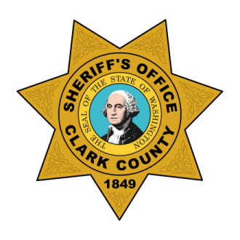
Clark County Sheriff’s Office
COVID-19 Update
The Clark County Sheriff’s Office will continue to protect and safeguard our community. We continue to work in partnership with Clark County Public Health, the Clark County medical community, CRESA and our other local law enforcement agencies and first responders.
In an effort to further protect the community and our own first responders from the spread of COVID-19 we have added the following additional safeguards, which are now posted at our Sheriff’s Office downtown campus location.
- Main Jail Lobby hours of operation: Monday – Friday, 8 am – 5 pm
- All professional inmate visiting will be limited one (1) person from the inmate’s legal representation. Should a translator be needed, please contact a jail commander to authorize a second visitor per visit.
- All personal inmate visiting will be limited to on-line. At the Main Jail one (1) person may visit in the jail’s available lobby kiosks. For at home use contact: https://www.gettingout.com/
- Phase 2 update: All non-criminal fingerprinting services have resumed. Concealed Pistol License (CPL) services are available to applicants residing in Clark County or in another state. Fingerprinting services are available to Clark County residents only. Fingerprinting and CPL services are provided by appointment only to minimize the health safety risk due to COVID-19. Call 564.397.2211 to schedule an appointment.
- All Commissary and Telephone Kiosk access to place funds on an inmate’s account will be limited to one (1) person at a time.
- All District Court Out of Custody Reporting for Sentences still need to report to the jail; paperwork documenting timely reporting will be processed and then the report date will be changed per District Court orders.
- No property releases from the Evidence Unit to Public; call 564.397.2059.
- No DNA shall be submitted to the Evidence Unit from the public; call 564.397.2059.
- No in-person PDR requests; call 564.397.2101.
These changes will be reviewed periodically as the COVID-19 pandemic situation continues to evolve.
Additional Information can be found at https://www.clark.wa.gov/sheriff or call 564.397.2211.
We thank you for your continued understanding and support as we work through this COVID-19 pandemic.

