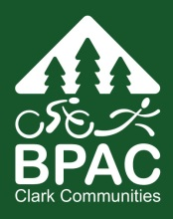 | Clark Communities Bicycle and Pedestrian Advisory Committee  Date: Tuesday, January 24, 2017  Time: 6:00 PM to 8:00 PM  Location: Center for Community Health  1601 E Fourth Plain Blvd., Vancouver, WA 98660  Conference Room 210 C  ----- Meeting Agenda -----

General welcome – 5 minutes

Review of Action Items - 5 min

Public Comment - 5 min

New Business – 60 min
  - WS DOT Bike Count locations
  - 50% Plan set review NE Kelly RD/Lucia Falls RD

Old Business – 25 min
  - Final 2017 Work Program; 15 min
  - City of Vancouver’s Complete Street Policy stakeholder committee; 10
  - NE Blair Rd improvements

Staff Updates – 15 min

City of Vancouver bike and ped advisory committee

Announcements & Updates – 5 min

