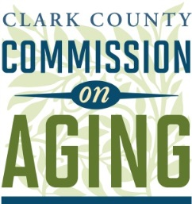

Clark County Commission on Aging

1300 Franklin Street, 6th Floor

Meeting Notes

Tuesday, May 15, 2018 4:30 p.m. – 6:00 p.m.

**Members Present:** Marian Anderson, Ali Caley, Chuck Frayer, Amy Gross, Pat Janik, Marjorie Ledell, Temple Lentz, and Linda O’Leary

**Members Absent:** Donna Roberge

1. **Welcome and Call to Order:** Marjorie Ledell opened the meeting.

**Approval of Agenda**: The agenda was approved by the commission.

**Approval of April 17, 2018 Meeting Minutes:** The April 17, 2018 meeting minutes were approved by the commission.

1. **Public Health Advisory Committee Update:** Amy Gross provided an update. This group is focused on food insecurity and other youth issues. They are interested in working more with us and developing that connection.
2. **Area Agency on Aging & Disabilities of Southwest Washington (AADSWA) update:** Marian Anderson provided an update. May is Older American’s month. Marian shared an overview of COA, the Aging Readiness Plan, COA recommendations and publications. The group debriefed Senior Lobby Day and watched a presentation from an RN.
3. **Presentations: Community Transit and Technology**

Whether transportation is provided by transit, public or non-profit providers, volunteer drivers or neighbors, ensuring access to safe and affordable mobility options for those who do not drive is critical to an individual’s ability to live independently.

**Colleen Kuhn** discussed the key role that the Human Services Council plays within the transportation industry.

**Community Transportation Options Serving Clark County**

* What is a community transportation provider?
  + Local organizations including government, non-profit, volunteer and private for profit agencies.
  + Community transportation providers often provide services outside the transit district and above and beyond what the ADA requires.
  + These trips can be private pay by the individual, private pay insurance or contracted services.
* Human Services Council
  + Non-profit organization incorporated in 1957.
  + Mission: The Human Services Council provides people with access to services, transportation and volunteer opportunities to impact their lives and strengthen our Southwest Washington community.
  + Serves SW Washington
  + Operates transportation and volunteer programs
  + Governed by a volunteer Board of Directors
* Matrix of services
  + Human Services Council:
    - Non-Emergency Medical Transportation.
      * This is made up of six different contracted organizations contracted.
      * It serves individuals covered by Medicaid and includes a call center, door-to-door or through-door services.
      * Day or monthly passes can be provided if a person has medical trips that qualify.
      * Gas vouchers can be provided to individuals with proof of insurance, driver’s license, etc. HSC has agreements with fuel companies in the area so clients can get fuel.
    - Reserve-A-Ride Transportation.
      * Funded through a consolidated grant. C-Tran 5310 funds are involved.
      * Provides rides to those who are not eligible for the Medicaid transportation.
      * There is currently no waiting list in Clark County for the first time in long time.
      * Since there is capacity, the service can be used at the moment for general medical trips, shopping trips, etc.
    - Employment Transportation and Bike to Work.
      * Funded through WSDOT.
      * For job training, jobs, job interviews.
    - Sponsor-A-Ride Transportation.
      * Funded by small donations, i.e. families are remote and sponsor an account for an older parent here.
      * Why use this instead of a taxi? HSC does a good deal of vetting and training so that individuals can feel comfortable and confident that HSC services are safe.
    - Mobility Management.
      * Partner with C-Tran on this.
      * Received support from COA to hire a mobility coordinator for the county. Bill Baumann was hired for this role.
      * Bill facilitates a local coordinating coalition and emergency management for the community.
      * Bill has had several small successes. One example: he helped get funding for a battery replacement for a person’s electric wheelchair. Another example: he worked with City of Vancouver on crosswalk signals and alarms for a woman with visual and hearing impairments who had to go out of her way to get to a bus stop safely. Both the City of Vancouver and C-Tran have been responsive partners so far and Bill has become a strong advocate for the community.
    - 1 Call/1 Click Trip Resource Center (1/1 TRC).
      * Funded through a transportation and community living grant which funded technology projects.
      * More details on this project are described below.
  + Other Community Transportation Services/Providers
    - Catholic Community Services/Volunteer Chore
    - Area Agency on Aging and Disabilities of SW Washington (AADSW). HSC Coordinates trips for the AADSW case managers.
    - Villages Clark County. Just starting to collaborate. Villages approached HSC to see if they could help with volunteer training and vetting.
    - Community Providers (i.e.: Carter Park)
    - Disabled American Veterans
    - American Cancer Society – Road to Recovery
    - Senior Living Facilities
* One-call/One-click trip resource center
  + Website and Call Center developed and operated by the Human Services Council.
  + Serves SW Washington (expanding soon)
  + User friendly resource to help people get where they need to go
  + Specific categories for seniors, people with disabilities, individuals on Medicaid and Veterans; offers additional resources specific to individual categories
* Planning & important community partnerships
  + Update to Coordinated Human Services Transportation Plan (CHSTP)
    - <https://www.rtc.wa.gov/programs/hstp/update/>
    - Currently working with the Regional Transportation Council on the update to the CHSTP.
    - Required by the federal transit administration.
    - You can fill out their survey on the website above and provide feedback.
  + Accessible Transportation Coalition. This group discusses transportation needs and how to address them. The group is funded through a technical assistance grant from Easterseals. The project was 1 of 10 selected from across the country.
  + C-TRAN
  + Healthcare Providers
  + Community Service Providers
  + Private Business
  + Community transportation includes everybody, from fixed route to for-profit and non-profit, to make resources available to those who need them.
* What’s next?
  + Completed Update to CHSTP
    - The local coordinating coalition is very involved with this initiative.
    - Once updated, the group will identify needs and propose solutions.
    - WSDOT grants: a project needs to be in the CHSTP to be considered for funding.
    - Will need to evaluate and rank projects in the region.
  + Expanded Accessible Transportation Coalition
  + Volunteer and Driver Training Project. Catholic Community Services does lots of volunteering, but HSC needs more help than even they can tackle. HSC wants to develop a comprehensive driver training program involving classroom/online training and hands-on training.
  + Community Vanpool: Hoping to partner with C-Tran or other private company for a vehicle for this project. The vehicle could be used by volunteer drivers and the HSC driver training program.
  + Expansion of the 1/1 TRC outside of the county.
  + Engagement of Transportation Network Companies, such as Uber and Lyft.
    - In the past legislative session, a number of bills were discussed regarding the regulation of companies like Uber and Lyft.
    - The only item resolved was the creation of a task force to look into these companies and how to ensure all providers, especially those serving vulnerable populations, have the appropriate vetting and training.
    - There is a lot of discussion about how to engage transportation network companies, especially in rural communities, and how to help fold them in as part of the overall transportation network.
    - It is really important to engage the communities and populations you want to serve. At a recent conference, I encouraged big players in the transportation network and autonomous vehicle business to get connected to the rural communities and the populations that really need the service.
    - We need to look for champions to help folks be comfortable with these new options.
    - HSC cannot currently use organizations such as Uber or Lyft because HSC contracts require a higher level of background checking and vehicle records checking than are provided by these companies. HSC insurance companies won’t cover these companies either.
    - We should keep working on figuring out how to fit these companies into the puzzle because we need all the resources can get.
  + Driverless Vehicles

**Questions and comments from COA members with speaker’s responses:**

**Comment:** Is there a due date to provide comments on the CHSTP? **Response:** The draft is expected to be complete by September. Lots of outreach is being done now and feedback is appreciated at this time.

**Comment:** We heard a lot about transportation for medical appointments. What about transportation for other needs? **Response:** We are very limited through our agency. Catholic Communities may be a good resource. Our reserve a ride program at this moment can provide some additional rides, but that is not always the case due to limited funding. I am working with WSDOT who does the statewide CHSTP. Our homework is to identify the one unmet need that keeps us up at night. For me, this is what I think about. While we don’t meet all needs, we do ok with getting people to their medical appointments. But, there is more to life than that. I hope the driver training program can help. I also hope group trips can help with transportation options.

**Comment:** You mentioned serving rural areas. Are you holding some of the CHSTP outreach/forums in rural areas? **Response:** Yes. WSDOT is very prescriptive in the type of outreach that needs to happen.

**Comment:** Also in regards to rural areas. We know C-Tran is not able to serve rural areas. We, the Commission on Aging, have started talking about Lyft, Uber, and the possibility of a discount for seniors, to encourage to people to use this kind of transportation. Has there been any discussion about this with what you have been involved with? **Response:** It seems to me like Uber and Lyft are very creative in how they are approaching transportation, such as bringing nurses out to the communities and delivering groceries in rural areas. There has not been much discussion about discounts. Part of that is the concern about the level of vetting. I have heard horror stories about Uber and Lyft, which is why our insurance company won’t support use of services in their contract. There is a Medicaid broker who is engaging Uber and Lyft through reimbursement of clients who self-book. This could be something to explore, but, we need to understand what the community wants. **Comment:** Youbring up excellent point of taking advantage of seniors.

**Questions and comments from the audience with speaker’s responses:** none.

------------------------------------------------------------------------------------------------------------------------------------------

**Kevin Chambers** is an independent consultant through Full Path Transit Technology, focusing on the intersection of technology, mobility and human services. He identified key technologies that are driving change in transportation and the resulting emerging industry trends.

**Mobility in the Tech Gilded Age**

* Key Technology Trends. There is a lot going on. We are at the cusp of sea change for how transportation happens for people.
  + User-facing trends
    - Mobile Devices
      * Multi-purpose
      * Networked
      * Location- & environment-aware
      * Personal avatar in the internet
    - Cost of Communication Approaching Zero. The sheer quantity of information being transferred back and forth is orders of magnitude larger than it’s ever been, and it’s growing.
      * Question now is “Should We?” rather than “Can We?” Over- communication and saturation of communication is becoming the bigger issue.
  + Transportation industry trends
    - Vehicles Will Be:
      * Connected. (Many already connected because we’re in there with smart phones.)
      * Shared. (i.e. Uber)
      * Electrified. (Growing quickly, the largest companies are Volkswagen and Toyota.)
      * Automated
      * FAVES  
        (Fleets of AutonomousVehicles that are Electric and Shared). Fleets is a key term because we often think of individual vehicles per person. Imagine electric, automated minibus in your neighborhood.
  + Tech sector trends
    - Big Players: top companies in the world are technology companies
    - Internet of Things. Gadgets with internet connectivity, relaying information. Think of vehicle fleets all connected to the internet, where lots of information is gathered and then used to optimize services.
    - Big Data: the scale at which we are aggregating and accumulating data is mind boggling.
    - Artificial Intelligence: applied to the big data. Systems make decisions based on a lot of information, more than a human could process.
    - The Cloud: all this is happening in the cloud. This is a marketing term for computing on someone else’s computer.
    - (X)aaS – Everything as a Service. Now, more and more things are being provided as a service. For instance, you can buy a call center as a service, or payroll as a service. This is penetrating the economy – we don’t need to own stuff, we can just pay someone else and get what we need.
* Mobility as a service (MaaS). AKA: mobility on demand, transportation as a service. Watch for this term, you will be hearing of it more.
  + Goal of MaaS: To provide a comprehensive package of transportation services that can replace personal vehicle ownership. You could sign up for an account instead of owning a car. A key factor of age friendly communities: how easily can you get out and around without a car?
  + Key MaaS elements
    - Easy Discovery: find out about options
    - Easy Decision-Making: figure out which option you want to use. Price is big here.
    - Easy Booking
    - Easy Mode Transfers: can easily switch between modes. This can help with first mile/last mile issues. Imagine if Uber/Lyft/Bike share/or another service could bridge gaps.
    - Easy Payment: if switching modes of transportation, it can all be paid for through one instrument.
  + A few select MaaS players

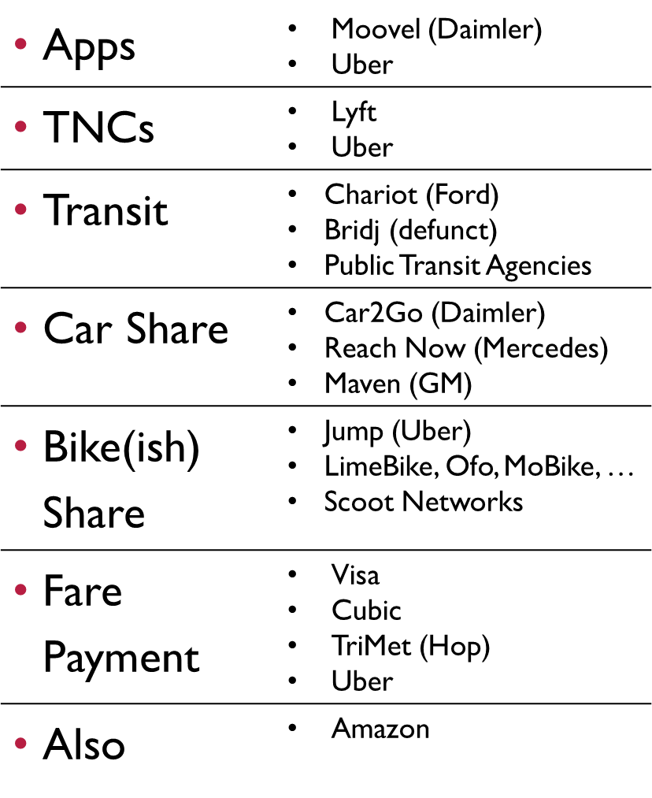

* + - Uber has apps for their own service and for other services
    - TNCs will be the grout between larger modes
    - Chariot = private, flexible transit service in a few cities
    - Bridj = in Washington, DC and Kansas City. Venture capital funded.
    - Public transit is on the list, but not much is happening because venture-capital funding isn’t a thing with public transit.
    - Bike(ish) share: scooters, bikes, etc.
    - Fare payment: Hop platform is used in the area by TriMet, C-Tran and the Portland Streetcar.
    - Amazon: if you flip mobility as a service on its head, then it’s stuff coming to you instead of you going to get it.
    - There is a lot of motion and money involved. The big players don’t know what to do, but they know things are changing and everyone wants a stake. That’s why large auto manufacturers are getting into things like car shares.
  + Easy discovery
    - Requires
      * Apps. Won’t work without instant access to options.
      * Data Sharing: how are all these services going to communicate services?
      * Data Standards: behind the scenes
        + General Transit Feed Spec
        + GTFS Real Time
        + GTFS Flex. Flex = demand response services
    - Challenges
      * Tragedy of the Commons
      * The standards benefit everyone in general, but no one in particular.
      * A little bit of federal funding, but mostly a stone soup process.
  + Easy decision-making
    - Requires
      * Apps
      * Market-Based Pricing. Cost is a key factor.
        + Ideally, you want to know the cost of the service and be market-based/pay what it costs to provide that service.
        + But, very few elements of the transportation industry work that way. Car ownership is subsidized. Lots of costs are not paid for, such as pollution, congestion, etc.
        + On the TNC side: they are propped up by a lot of venture capital. Uber is losing roughly half a billion dollars per month. Current prices reflect subsidies. A lot of transportation infrastructure is not in good shape because we’re not fully paying for it.
    - Challenges
      * Subsidies
        + Venture capital
        + Infrastructural debt
        + Other externalized costs
  + Easy booking
    - Requires
      * Apps
      * Standardized Application Programming Interfaces (APIs). So systems/platforms can talk to each other.
      * Vendor API Terms of Use That Presentation With Other Options
    - Challenges
      * Subsidies
      * Anti-competitive API Terms of Use. Uber generally does not allow the use of their API if competing services show up alongside. This is a key policy area and could be addressed through regulations.
  + Easy mode transfers
    - Requires
      * Apps
      * Big Data (Sharing). If running late, Uber driver knows and can adjust. Uber is making money off of the ride and data bout the ride. Data sharing could be part of the regulation.
        + Historical
        + Real Time
      * Good Design
    - Challenges
      * Research Needed
      * Institutional Barriers
  + Easy payment
    - Requires
      * Apps
      * Data Standards
      * Mobility Accounts
    - Challenges
      * Institutional Barriers
      * Bringing Competitors to the Table
      * Affordable Micropayments (credit cards are fairly expensive as form of payment)
  + Other MaaS Requirements
    - Central “Mobility Manager” Role
      * Everyone wants to be the hub.
        + In the private sector, everyone wants to be the place to get “x.”
        + Amazon gets that for online purchasing. Google gets that for online searching. Facebook gets that for social networking.
      * Complex role that’s easy to abuse
      * How to get both agility + public interest?
      * Business models matter. A lot.
      * Transportation trusts?
        + This idea could be something like the Energy Trust of Oregon, where the trust gets some of the utility bill and helps everyone to conserve energy because power companies are not interested in energy conservation.
    - Density
      * Currently pencils out in urban areas. The more dense, the easier it is.
      * Changing that will require thoughtful policy & planning
      * Automated fleets. Could help some of the challenge.
      * Integrated community-based transportation. Important to bring community organizations on board.
  + Challenge: it’s still early
    - Garner Hype Curve, 2016, edited by Graham Currie:
    - Could apply this graph to mobility as a service in general. It’s still early and it is not clear how things will pan out.
  + The opportunity: Universal MaaS
    - Fully Include People with Barriers to Mobility. This includes: older adults, those with disabilities, and those in rural areas.
    - Reduce the Need for “Parallel” Services
    - Universal MaaS Can Make “Conventional” MaaS More Workable for the General Public. If you build it for those with barriers, it will serve those who don’t have barriers.
    - Where Innovation and New Business Models meet Equity, Inclusion, and Social Outcome Goals
      * Age-Friendly Communities
      * Aging in Place
      * Mobility as a Form of Healthcare. Transportation well executed, can be a form of healthcare.
    - We need to be at the table for these smart cities/whiz-bang conversations early and often. This is the main takeaway.

**Questions and comments from COA members with speaker’s responses:**

**Comment**: Do we have a sample policy to look at? **Response**: I would love to be part of that. **Comment**: What does it look like? **Response**: Looks like regulation of the services. My world is the tech world, and I don’t know a lot of the policy tools that well. I would love to talk with a planner on what it would look like. Public-private partnerships need to be able to happen. They can’t happen just through government action. We need the agility and opacity of the large players. If they can connect with communities/grassroots, a lot is possible.

**Comment:** In light of Facebook’s dark period and knowing we need to have all of this data to interact, can you speak about the risk with this data? **Response**: It is important to look at business models. They matter a lot. Someone might say we’ll be your mobility manager and won’t charge you. That’s a red flag. Ideally all these modes, every time you choose a mode, you pay fully for the transport and service of mobility manager. Instead, we often pay by giving up our privacy.

**Comment:** Does Jana Lynott have a policy? **Response**: She is working on it through AARP, it should be available this fall. I have been involved in reviewing a part of it.

**Questions and comments from the audience with speaker’s responses:** none.

1. **New Business, Updates and Announcements:**
   1. Member and staff recognition. Marjorie Ledell presented certificates of appreciation to two Commission on Aging members who are completing terms of service and to two county staff members who have helped support the commission.
      * Chuck Frayer, Commission member for 6-years
      * Pat Janik, Commission member for 3-years
      * Colete Anderson, county staff
      * Sharon Lumbantobing, county staff
   2. No Commission on Aging meeting in June due to Commission retreat.
   3. The COA Speaker Series continues on July 17, 2018 with Senior Drivers and Safety with presenter Tom Wilson from AARP.
2. **Adjournment:** Meeting adjourned at 5:58 pm

***The Clark County Commission on Aging provides leadership and creates community engagement in addressing the needs and opportunities of aging.***