CLARK COUNTY CORRECTION FACILITY ADVISORY COMMISSION

Clark County Council Chambers
Public Service Center
1300 Franklin Street

July 10, 2018
3:00pm – 6:00pm

AGENDA

Attendance
Commission: Commission Chair Craig Pridemore (At-Large), Vice Chair Chief James McElvain (City of Vancouver), Chief John Brooks for Steve Stuart (City of Ridgefield), Louis Byrd (Byrd Legal Servics), Carmen Carabello (Esther Short Neighborhood Association), Bob Carroll (IBEW), Judge Scott Collier (Clark County Superior Court), Vanessa Gaston (Clark County Community Services), Tony Golik (Clark County), Eric Holmes (City of Vancouver), Mayor Ann McEnery-Ogle (City of Vancouver), John Moren (Community Services NW), Kim Mosolf (Disability Rights Washington), Judge Kelli Osler (Clark County District Court), Chief Bob Richardson (City of Battleground), David Scott (City of Washougal), Melissa Smith (City of Camas), Mayor Greg Thorton (City of La Center)

Officials/Staff/Interested Parties: Leah Becknell (Beacon Health Options), Mike Bomar (Port of Vancouver), Sean Philbrook (Identity Clark County), County Chair Boldt (Clark County), Marlia Jenkins (Clark County), Chief Ric Bishop (Clark County), Erik Jensen (Jensen Strategies), Alice Cannon (Jensen Strategies), Ann Kuan (Jensen Strategies)

Welcome/Opening Remarks
The meeting was opened at 3:00 p.m. by Chair Pridemore. Meeting minutes from the June 26th meeting were unanimously approved by the Commission.

Work Plan Overview
Erik Jensen said that the next few meetings will be spent discussing criteria by which recommendations should be evaluated. The past few meetings were intended to gather background information to guide decision making in September and October. During August, a public opinion poll will be conducted by Davis Hibbitts Migdall to gather insights about the jail need from a sample of 500 Clark County residents.
Carla Weinheimer Presentation- 2016 DLR Report

Carla Weinheimer was the project manager for the DLR 2016 Jail Master Planning effort.

The factors considered in the Master Plan Process
- Jail Capacity - How the current site can change to fit the needs in the future
- 3D Operation Flow - Optimizing the flow of users reduces risk and congestion, as well as unnecessary operational expenses
- Integration of Justice Needs- Ensure that there is easy access to assessment, medical, diversion, courts, community service, etc.
- Site Constraints and Phasing
- Urban Design Approach- If the jail is to be in an urban setting, it needs to blend in with existing urban design elements
- Future “Proofing”- Structurally, how can the jail expand in the future. How can the jail be phased over time without disrupting its function

The Preferred Master Plan

The 2016 Master Plan concluded that the preferred plan is to renovate the existing jail into jail administration space, and expand housing and other services to the area around the jail. This can be seen in the following diagram:

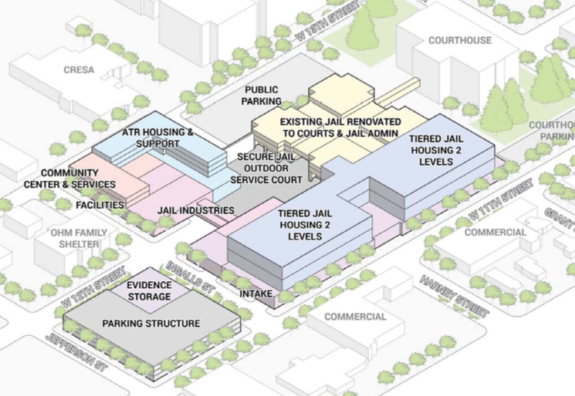

This Preferred Master Plan solves several problems the current jail has:
- Secure Jail Outdoor Service Court - The current jail does not have a secured space for transferring incoming inmates. Creating a secured courtyard not only solves this problem, it also provides a secure exterior space for evacuation when necessary.
- Parking - An additional parking structure will be built, which increases the amount of parking available for staff and visitors.
- Housing - This plan features four two-tiered housing blocks that can be constructed in the future to accommodate jail population growth. Furthermore, these housing blocks are identical, which increases staffing efficiency.
- Shelter Housing - Shelter housing will provide a space for inmates released at night to stay until they are ready to integrate back into the community.
Q & A from CFAC Members Included:

Q: Couldn’t this block go anywhere, not just downtown?
A: Technically it could. Proximity to the courts reduces costs of transportation for inmates.

Q: Urban development tends to be expensive. Is it possible to re-locate the jail to cheaper land outside of downtown? Have other sites been analyzed to determine if a site outside the downtown would be cheaper?
A: No other sites were analyzed. The key reason was the need for an easy connection to the court. Existing services are also in close proximity to the existing jail site.

Q: Parking currently is constrained around the jail. Will this new plan guarantee new parking?
A: Land acquisition cost is in the budget, and County staff is confident this plan would provide more parking if nearby land is acquired to build a proper parking structure.

Chief John Chapman Presentation- Mackenzie Report Briefing

Chief John Chapman reminded the Commission that the Mackenzie Report can be read on the Clark County website. The report outlines options for the sheriff’s administrative offices when the jail is renovated or moved. Those options are:

Plan A: Move the sheriff precinct elsewhere
Plan B: Move records and the sheriff administrative offices
Plan C: Move evidence and logistics structure

Social Services and Diversion Programs Presentation

This presentation is a high level look at social services and diversion programs, the systems they work in, and how people flow through the system.

Clark County Mental Health Crisis System has three phases of treatment
- Point of Entry- People can enter the system through a variety of channels, such as jails, schools, family, etc.
- Service Received- Once the system has been contacted about the patient, there are a variety of services available, such as:
  - Mobile Outreach - The mobile outreach team works to de-escalate the situation and keep patients out of jail. Detainment is always the last resort.
  - Assessment - The outreach team assesses patients to see what their mental health needs are, and direct them toward the best resource.
- Exit- After assessment, patients are either sent home, hospitalized, or referred to other services.

Gaston highlighted the following three components of the current mental health and SUD systems:

Clark County Mental Health Adult System-
- Point of Entry
- Assessment
- Patients are directed toward appropriate level of care. The levels are as followed:
- Peer/Recovery Services
- Outpatient (clinic based)
- Community Support Team (community based)
- PACT Teams (community based)
- Elahan Place (residential)
- Housing

Clark County Substance Use Disorder (SUD) Crisis System
- SUD is a brain disease. If someone can get sober before entering the jail system, they save the jails system a lot of money.
- There is a lot of Recidivism is common within inmates who have SUD.
- Ricky’s Law- Allows involuntary commitment to chemical dependency treatment if a person is at risk of seriously harming themselves or others

Clark County SUD System
- Point of entry
- Detox or Sobering Center- Patient is assessed (12-24 hrs)
- Based on the assessment, patients are directed to the care they need, including short-term residency or intensive out patient treatment
- Recovery programs and housing

Gaston also mentioned the two following factors:

Access to housing programs
- Housing solution center- Assess the situation and try to move people out of homelessness.
- Outreach teams try to go out and engage people
- We are not just building shelters, we need to think of the outcomes. Shelters are not permanent solutions.
Diversion
- The goal is to empower a household to identify a housing solution without entering the system in the first place.
- Reduce barriers to housing
- Includes: coaching, mediation, education, landlord engagement

Q&A from CFAC Members Included:

Q: Do people exiting jail qualify for housing assistance?
A: Since they were in jail before, they are considered “housed”, and thus do not qualify for housing assistance. They need to be homeless first. This is a problem in the system that needs to be solved.

Q: Are there housing services for people immediately out of jail?
A: There are no specific housing services dedicated to people coming out of jail. There is some rental assistance for people in recovery from behavioral health disorders through the County’s Access to Recovery Program.

Q: Homelessness has become more visible recently. Is there record of an increase in homelessness or has it stayed about the same?
A: There has been an increase, but now we are seeing more families and children. There are a lot of people who work and live in their car. The housing vacancy rate is so low, it is hard for people to find housing.

Q: How does a community outreach team work?
A: Adult Mobile Crisis - For anyone who is experiencing crisis that is not on the cusp of detainment, the outreach team will show up within 90 minutes to provide an assessment, put support in place, and follow up after seven days to ensure the patient is following through.
Homeless Outreach Team - There are four teams managed by Janus Youth, Share, and CSNW. The teams operate during the day M-F and people can call the organization to access them. Janus Youth focuses on individuals under the age of 24 and helps them by initiating contact and connecting them to local resources. Share and CSNW both focus on individuals under 18.

Q: Do you run background checks on people to see where their problems originated?
A: A lot of people who are now homeless have experienced trauma in their youth. Providers will do assessments to see where they’ve gotten treatment before, their jail history. They use the same health care database. Most people in our services are long-term Washingtonians. Homeless population might be different. Assessment is learning about the life history.

Q: How do your program resources interface with the new jail?
A: Many treatment providers have strong belief in community-based treatment, so they may be opposed to bringing treatment into jail. The more important point is how do we prevent people from going into jail in the first place. If they do get arrested, how do we coordinate with the jail to get people into community-based systems. When someone is incarcerated, Medicaid is suspended, and that’s where Clark County gets funding. When you put money into a jail, you’re taking money away from programs that could be keeping people out of jail in the first place.

Q: Out of all the programs you’ve mentioned, do any of them prioritize law enforcement?
A: Clark County Crisis Services works closely with law enforcement when someone needs to be detained due to them harming themselves or others because of a behavioral health disorder. The crisis mobile response teams are also available to work with law enforcement.

Adjournment
Chair Pridemore adjourned the meeting at 5:28 p.m.

