**Date:**

**Name:**

Morning  Afternoon  Evening

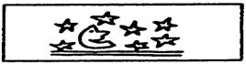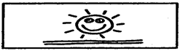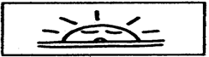

**Where?**

Home  School  Bus  Outside  Detention Other

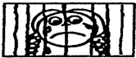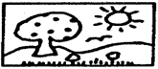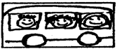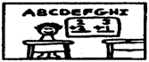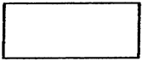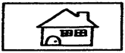

**What?**

Teasing  Fighting  Arguing

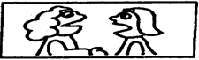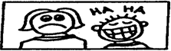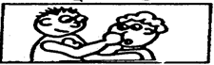

Somebody Somebody Did

Took Something  Something Wrong  Other

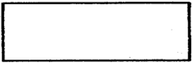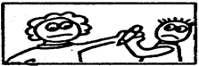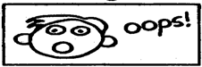

**Who?**

Friend  Parent Brother/Sister Teacher  Other

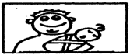

**What did you do? Action?**

|  |
| --- |
|  |

**How did you feel afterwards?**

Happy  OK  Sad  Mad  Scared



**How angry were you?**

**Super Mad**

**Not Mad**

**9**

**10**

**8**

**7+**

**6**

**4**

**5**

**3**

**2+**

**1**

**Date:**

**Name:**

**5. Reminders:**

**1. External Trigger:**

**6. How I thought ahead (If . . Then . . )**

**2. Internal Trigger:**

**Short Term:**

**Long Term:**

**7. Social Skill:**

**3. My Body Signs:**

**4. My Anger Reducers:**

**8. Self-Evaluation:**

**Self Coaching:**

**Self Rewarding:**

**7a. Write Out The Steps For The Skill:**

**a1.**

**a2.**

**a3.**

**a4.**

**a5.**

**a6.**

**FILL IN AFTER DOING/PRACTICING THE SKILL**

**1. Describe the situation in which you used this skill?**

**2. Which steps did you really follow?**

**3. How good of a job did you do in using this skill (Check One):**

Excellent  Good  Fair  Poor

**4. How could you improve your use of the skill?**

**5. With whom will you try this skill next?**

**Parent/Guardian Signature**